Change Request Screen

This is a custom screen which was made to replicate a form with multiple levels of sign off depending on the size of the job. (See Change management Form update 20190129 for discussion.docx)

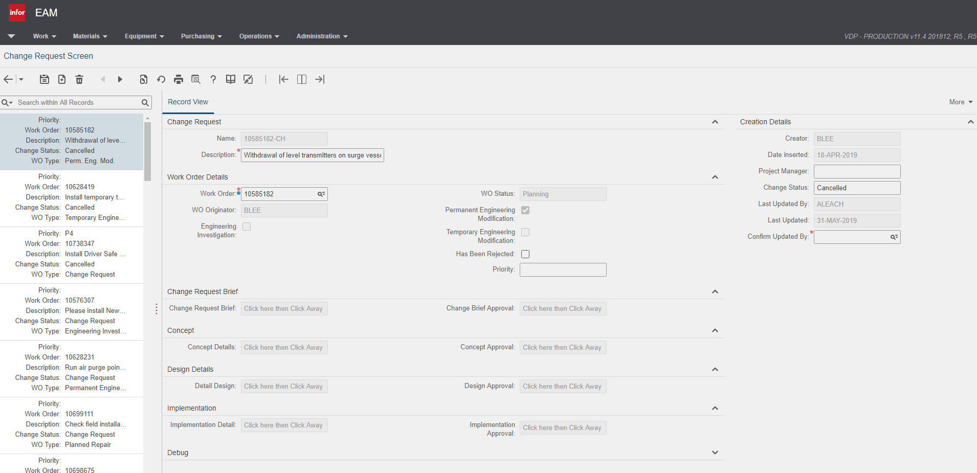

The screen is built in User Defined Screens,

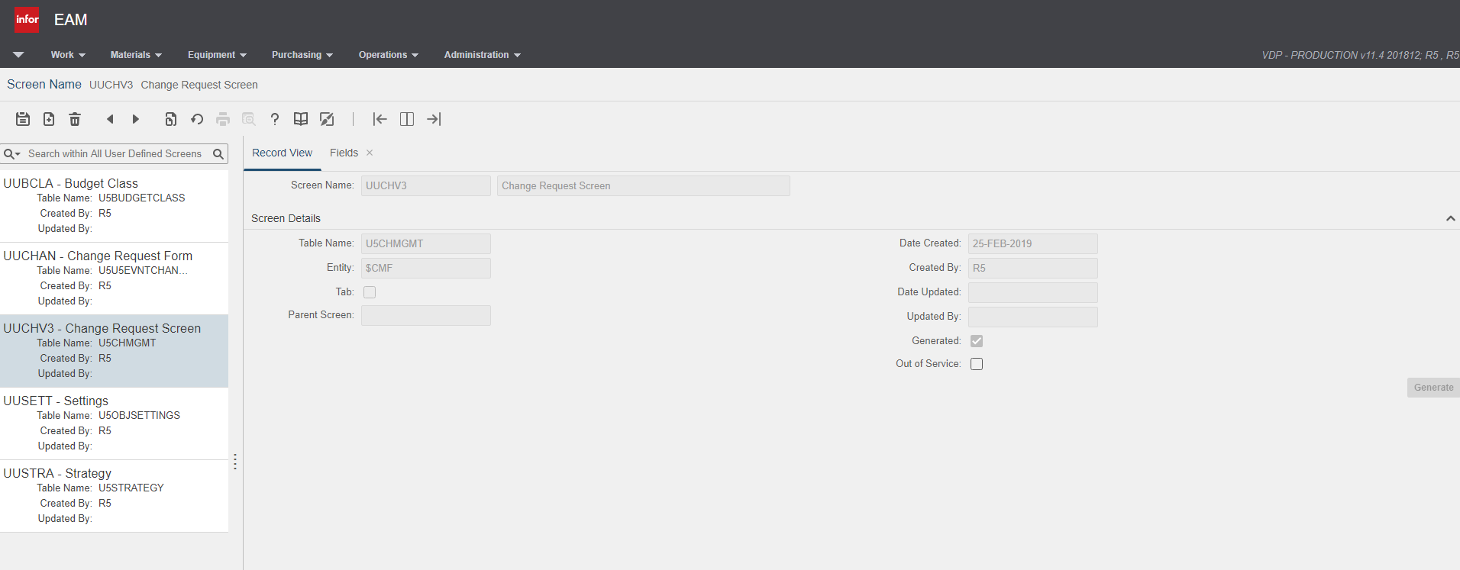

(For the fields setup see UUCHV3_Fields.xlsx there are 140 with the majority being free text fields)

Most of the retrieved value queries are pulling in the work order status etc to display on the page,  
The key field is generated by a querie and overwritten by flex to be the work order number “–CH” I do this because it restricts a 1 to 1 relationship between change forms and work orders.

The change request flow works in Parallel with the work order flow, the user changes the status of the work order to “Change approval”, then emails are triggered based on the work order status change to inform 4 approvers, once they have entered text (any text) it goes to the manager for approval.

Status changes etc are handled by the Flex’s

I have commented my javascript code, hopefully it gives you a clue on how I did it.

I have added some explanations of our work flow and the work flow of the change requests, if you find any errors or work out anything that works a little better let me know